WATER LEVEL INDICATION
BY USING 3 LEDS
INTRODUCTION: The water usage is more in now adays. Instead of using water, huge amount of water is wasting. Here we taking one of application is water tanks. Lots of amount of water is wasting by over flow water in water tanks. So, we need to reduce that factor by using simple project “WATER LEVEL INDICATION” that could be implemented by using Arduino uno board.
COMPONENTS:
- Arduino uno board
- Water level sensor
- Three different color leds
- Resistors (220 ohms-3)
- Jumper wires
- Bread board
- Buzzer
INDICATIONS:
- The first led is red color that indicates the water level is low (0-45%)
- The second led is yellow color that indicates the water level is medium (45-95%)
- The third led is green color that indicates the water level is high (above 95%)
- Buzzer is use to indicate the water level is high (above 95%)
COMPONENTS EXPLANATION:
- WATER SENSOR:
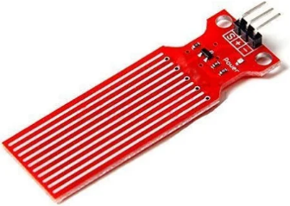
ADIY Water Level Sensor can be used as a water level alarm. Easily interfaced with an Arduino or other microcontrollers, and read through Analog Input pins.
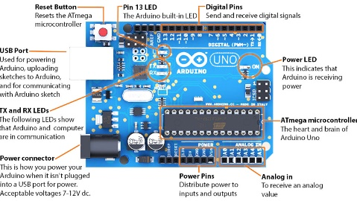
- ARDUINO UNO BOARD:

Arduino Uno is a microcontroller board based on the ATmega328P (datasheet). It has 14 digital input/output pins (of which 6 can be used as PWM outputs), 6 analog inputs, a 16 MHz ceramic resonator (CSTCE16M0V53-R0), a USB connection, a power jack, an ICSP header and a reset button.
- ATmega328 Microcontroller- It is a single chip Microcontroller of the ATmel family. The processor code inside it is of 8-bit. It combines Memory (SRAM, EEPROM, and Flash), Analog to Digital Converter, SPI serial ports, I/O lines, registers, timer, external and internal interrupts, and oscillator.
- ICSP pin - The In-Circuit Serial Programming pin allows the user to program using the firmware of the Arduino board.
- Power LED Indicator- The ON status of LED shows the power is activated. When the power is OFF, the LED will not light up.
- Digital I/O pins- The digital pins have the value HIGH or LOW. The pins numbered from D0 to D13 are digital pins.
- TX and RX LED's- The successful flow of data is represented by the lighting of these LED's.
- AREF- The Analog Reference (AREF) pin is used to feed a reference voltage to the Arduino UNO board from the external power supply.
- Reset button- It is used to add a Reset button to the connection.
- USB- It allows the board to connect to the computer. It is essential for the programming of the Arduino UNO board.
- Crystal Oscillator- The Crystal oscillator has a frequency of 16MHz, which makes the Arduino UNO a powerful board.
- Voltage Regulator- The voltage regulator converts the input voltage to 5V.
- GND- Ground pins. The ground pin acts as a pin with zero voltage.
- Vin- It is the input voltage.
- Analog Pins- The pins numbered from A0 to A5 are analog pins. The function of Analog pins is to read the analog sensor used in the connection. It can also act as GPIO (General Purpose Input Output) pins.

CONNECTIONS:
- Connect the water sensor of 3 pins, “+” pin is connected to ‘v_{in}’ pin of Arduino board and “– “pin is connected to ‘GND’ pin of Arduino board and “S” pin is connected to A₀ pin of Arduino board.
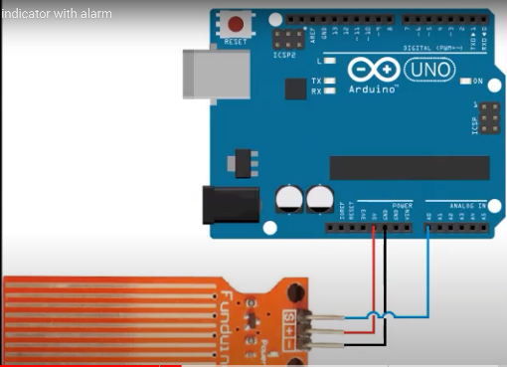
- Place the leds on bread board, all -ve pins of led are grounded give the inputs to 3 leds, first led is connected with a resistor in series to 13 pin of Arduino board.
- The second led is connected with a resistor in series to 12 pin of Arduino board and third led is connected with a resistor in series to 11 pin of Arduino board.
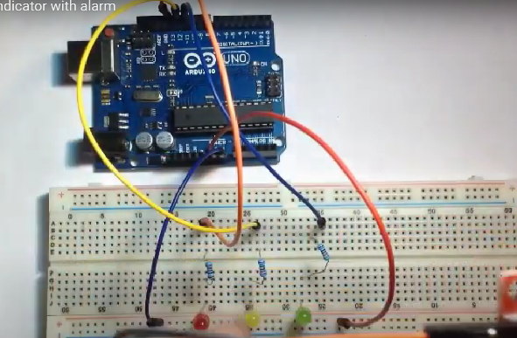
- The buzzer +ve pin is connected to 8 pin of Arduino uno board and -ve is grounded.
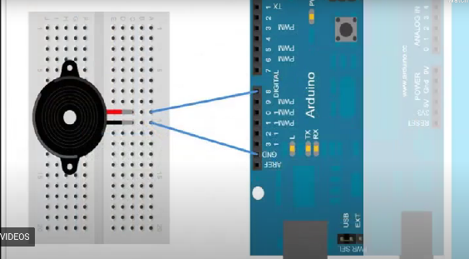
- The code is dump into the Arduino uno board.
- Give the 5volts supply it Arduino uno board
OPERATION:
- When the system is powered on, the Arduino will start reading the water level sensor's input.
- Based on the water level, the Arduino will illuminate the corresponding LED (green for low, yellow for medium, red for high) and activate the buzzer if the water level is too high.
- The system will continue to monitor the water level and update the LEDs and buzzer accordingly.
NOTE:
- Ensure that the current drawn by the LEDs and buzzer does not exceed the maximum current output of the Arduino's pins. If necessary, use external power sources or transistors to control them.

PROGRAM:
int level;

const int analog_0=0;
int l1=13;
int l2=12;
int l3=11;

void setup() {
// put your setup code here, to run once:
Serial.begin(9600);
pinMode(l1,OUTPUT);
pinMode(l2,OUTPUT);
pinMode(l3,OUTPUT);
pinMode(8,OUTPUT);
}

void loop() {

// put your main code here, to run repeatedly:
level=analogRead(analog_0);
Serial.println(level);
if(level>0&&level<600)
{ digitalWrite(l1, HIGH);
digitalWrite(l2, LOW);
digitalWrite(l3, LOW);
digitalWrite(8, LOW);

}
else if(level>600&&level<700)
{
digitalWrite(l1, LOW);
digitalWrite(l2, HIGH);
digitalWrite(l3, LOW);
digitalWrite(8, LOW);

}

else if(level>700&&level<800)
{
digitalWrite(l1, LOW);
digitalWrite(l2, LOW);
digitalWrite(l3, HIGH);
digitalWrite(8, HIGH);

}
}
OUTPUT:
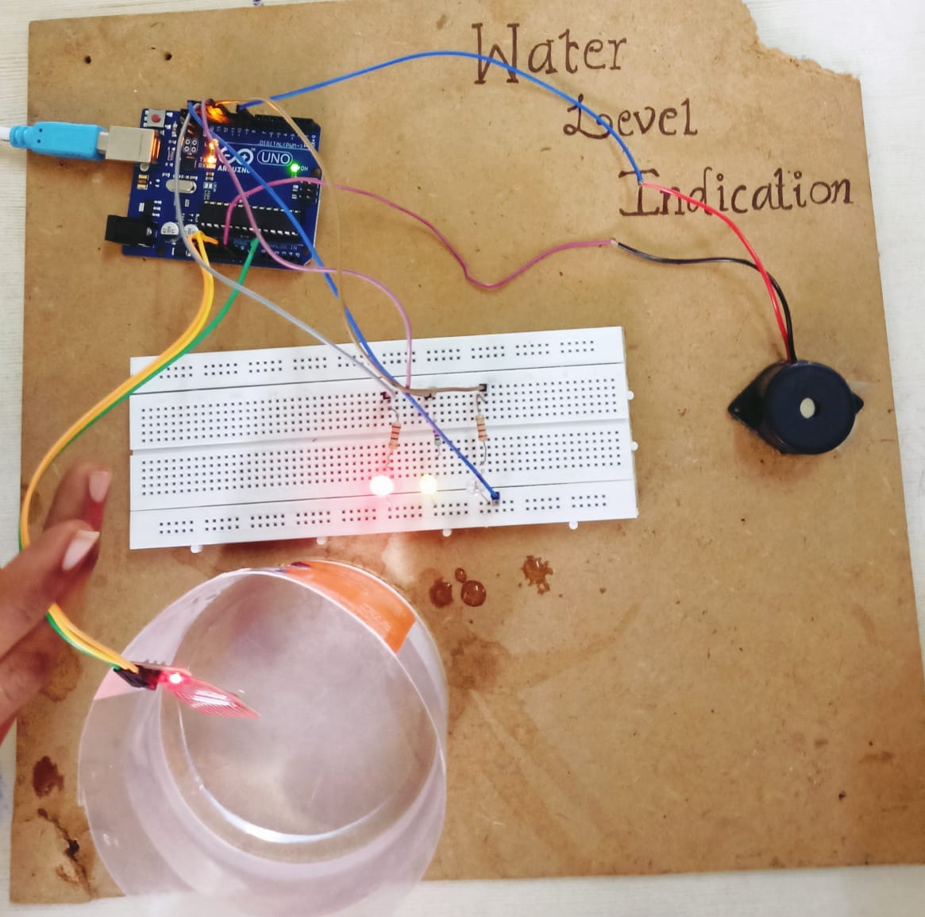
REFERNCES:
YOUTUBE:
      - https://www.instructables.com/Water-Level-Indicator-Using-Arduino-1/
CHAT GPT:
      - https://chat.openai.com/c/73f33797-ebc5-4d04-b9f0-b5ee48be17ae

